fs-RIDL Summary
Release of insects carrying a female specfic dominant lethal transgene. Males inheriting the transgene will live, but females will die. If sufficient numbers of males are released to monopolise female reproduction for a long enough period of time, the population will collapse.
Parameters
Lethality of RIDL (paper says 100%)
Fitness of RIDL population vs Wild type
number of releases
release population size
heterozygote male offspring fitness?
 | R | R
W | WR | WR
W | WR | WR
 | W | R
W | WW | WR
W | WW | WR
fs-RIDL homozygous male release fs-RIDL heterozygous male offspring

All offspring of a homozygous male will carry the female lethal transgene. As it is dominant, no female offspring will survive. Males will carry one copy of the dominant gene. Heterozygous male offspring will pass the lethal gene to 50% of offspring, the females receiving the gene will die.

TARE Summary
The “toxin” is CRISPR cas-9 and guide RNA which disrupts a haplosufficient gene vital to life. Those carrying two copies of the disrupted gene will die. The “rescue” is an altered version of the target gene which will not be disrupted by the Cas-9 as the gRNA will not target it. This biases inheritance by removing non-drive genes from the population.

If a heterozygous TARE carrying parent is female, maternally deposited Cas-9 has a high chance of disrupting both the wild genes (88-95% drive transmission by female heterozygotes, with Mendelian inheritance would be ~50%).
Female Parent  Cas9⁺  Female  Parent Cas9⁻ | Cas9⁺ T⁻ | Cas9⁺ T⁻ | Cas9⁺ T⁻ | Cas9⁺ T⁻
Cas9⁻ T⁺ | Cas9⁺ Cas9⁻  T⁻T⁻  Cas9⁺ Cas9⁻  T⁻T⁺ | Cas9⁺ Cas9⁻  T⁻T⁻  Cas9⁺ Cas9⁻  T⁻T⁺ | Cas9⁺ Cas9⁻  T⁻T⁻  Cas9⁺ Cas9⁻  T⁻T⁺ | Cas9⁺ Cas9⁻  T⁻T⁻  Cas9⁺ Cas9⁻  T⁻T⁺
Cas9⁻ T⁺ | Cas9⁺ Cas9⁻  T⁻T⁻  Cas9⁺ Cas9⁻  T⁻T⁺ | Cas9⁺ Cas9⁻  T⁻T⁻  Cas9⁺ Cas9⁻  T⁻T⁺ | Cas9⁺ Cas9⁻  T⁻T⁻  Cas9⁺ Cas9⁻  T⁻T⁺ | Cas9⁺ Cas9⁻  T⁻T⁻  Cas9⁺ Cas9⁻  T⁻T⁺
Cas9⁻ T⁺ | Cas9⁺ Cas9⁻  T⁻T⁻  Cas9⁺ Cas9⁻  T⁻T⁺ | Cas9⁺ Cas9⁻  T⁻T⁻  Cas9⁺ Cas9⁻  T⁻T⁺ | Cas9⁺ Cas9⁻  T⁻T⁻  Cas9⁺ Cas9⁻  T⁻T⁺ | Cas9⁺ Cas9⁻  T⁻T⁻  Cas9⁺ Cas9⁻  T⁻T⁺
Cas9⁻ T⁺ | Cas9⁺ Cas9⁻  T⁻T⁻  Cas9⁺ Cas9⁻  T⁻T⁺ | Cas9⁺ Cas9⁻  T⁻T⁻  Cas9⁺ Cas9⁻  T⁻T⁺ | Cas9⁺ Cas9⁻  T⁻T⁻  Cas9⁺ Cas9⁻  T⁻T⁺ | Cas9⁺ Cas9⁻  T⁻T⁻  Cas9⁺ Cas9⁻  T⁻T⁺

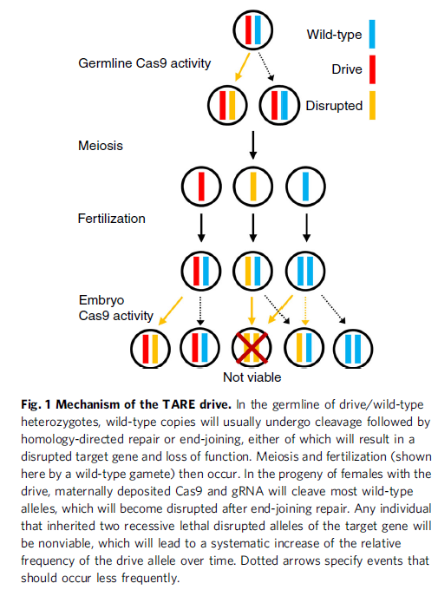
Where are parameters for each worth investigating?
Maternal deposited Cas-9 effectiveness.
Fitness of TARE population vs Wild type
number of releases
release population size

